EXPERIMENT 9

VIEWS

**Aim:**

1. Create table student with attributes id, name and department.
2. Display
3. Create view and select
4. Insert values
5. Create view with check option
6. Insert values and alter table.

1.



2.

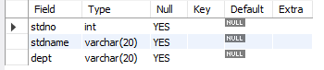

3.



4.

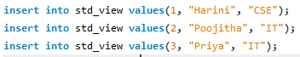

5.



6.

